# DESIGN ANALYSIS - **CRITERIA TABLE**

Note: we provide an example based on a flyer for a school event just to guide you how to complete this table.

To submit:

1. Individual work. Select 2 or 3 pages on a magazine to analyze.
   * You can select a paper magazine or a web magazine
2. **Insert screenshots of your magazine pages** you have selected regarding this design analysis work.
3. Replace the **last column with your design analysis**.
   * You can write in Khmer or English

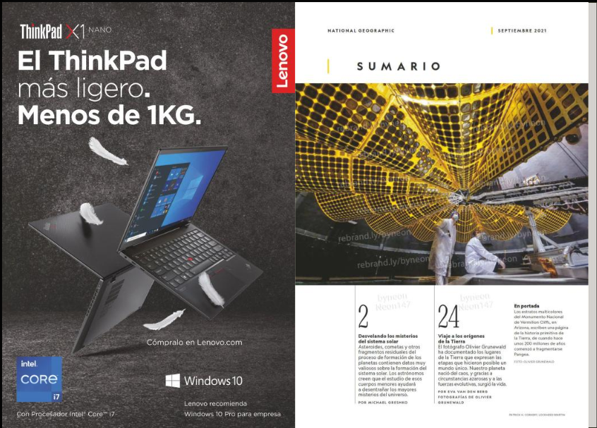

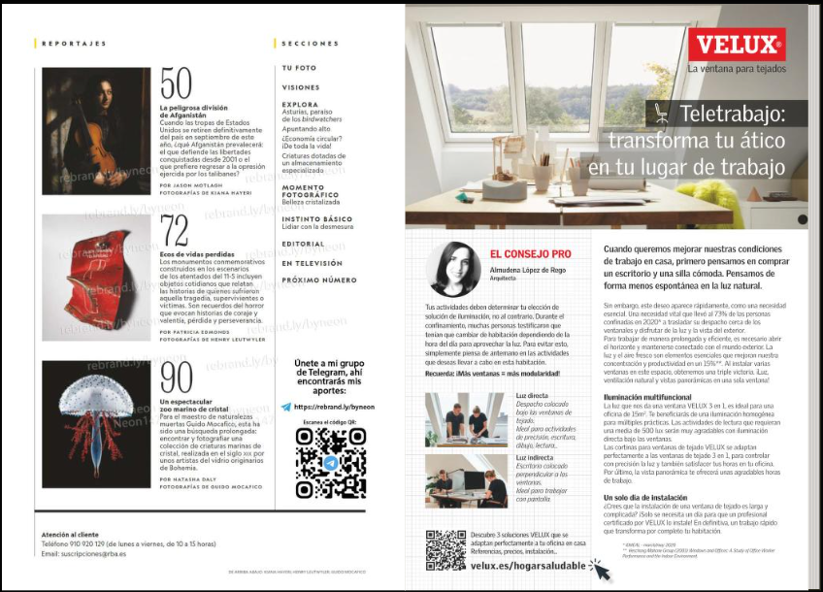

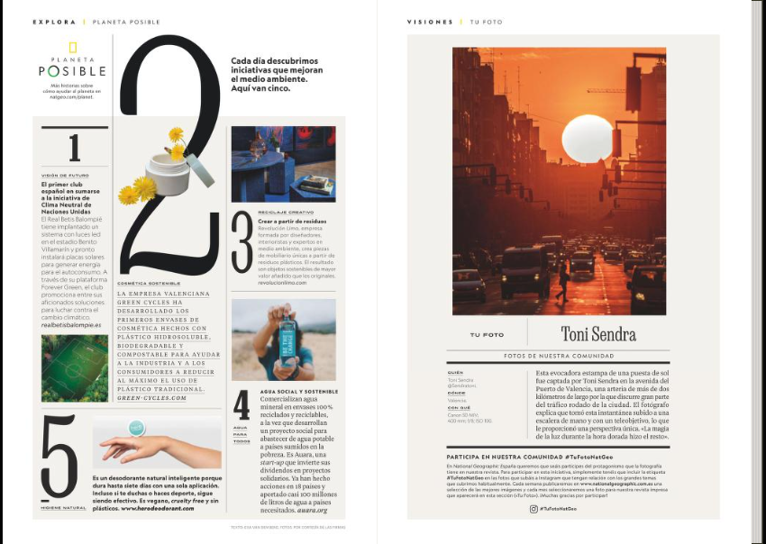

|  |  |  |
| --- | --- | --- |
| CATEGORY | CRITERIA | EXAMPLE OF ANALYSIS |
| **FONT** | The **fonts**, the **font size**, and style are well selected and create a visual **interest** | *The design uses a bold, light and eye-catching font for the event title, but the body text uses a small font that is difficult to look and read.*  *A lot of font style that make it difficult to look.* |
| **COLOR** | The **color palette** is well selected and create a visual **interest** | *The design uses a color black, white and the colors of image and creates visual interest.* |
| **COMPOSITION** | The layout of the design well-organized and **easy to follow**, with a clear **hierarchy** of information | *The layout of the design is well-organized and easy to follow, with a clear hierarchy of information, but it’s too much.*  *The use of white spaces are very clear.* |
| **CONTRAST** | Is there sufficient **contrast** between the different elements of the design to **make them stand out** and create visual interest | *The use of contras in the design is font style, font size and colors of the topics.*  *The event title stands out but the body text is too small.* |
| **BALANCE** | Is the design **balanced** in terms of its use of space, text, and graphics | *The design is well-balanced in terms of its use of space, color, and size of photos.*  *The event information is not clear, because* |
| **PROXIMITY** | Are related elements of the design **grouped** together to create **visual unity** and **hierarchy** | *The related elements of the design are grouped together effectively, with the event title, date, and location presented in a clear and organized manner.* |
| **REPETITION** | Is there consistent use of design elements (such as fonts, colors, and graphics) throughout the design to **create visual unity** | *The design does not make consistent use of design elements throughout the flyer, which could have helped to create visual unity.*  *For example, the use of the school logo could have been repeated throughout the design.* |
| **WHITE SPACE** | Is there sufficient white space (or negative space) in the design to create **visual breathing room** and balance | *The design makes good use of white space to create visual breathing room and balance.*  *The use of white space also helps to highlight important information.* |